1 Two powerline adapters establish the private network.
- For example：Powerline adapter 1, powerline adapter 2, establish the private network.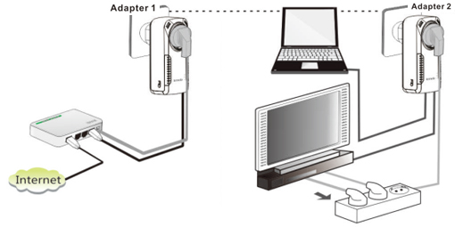
The steps of setting:
❶ Please keep pressing the Pair/Reset button of powerline adapter 1 for 1~3 seconds, the PLC light will blink.
❷ Please keep pressing the Pair/Reset button of powerline adapter 2 for 1~3 seconds in 2 minutes, the PLC light will blink. When PLC light of two powerline adapters changes into bright state normally, they establish the powerline network successfully.

2 The powerline adapter adds the private network having been established.
- For example: If the powerline adapter 1 and adapter 2 have established the private network N1, you want to add the powerline adapter 3 into N1.
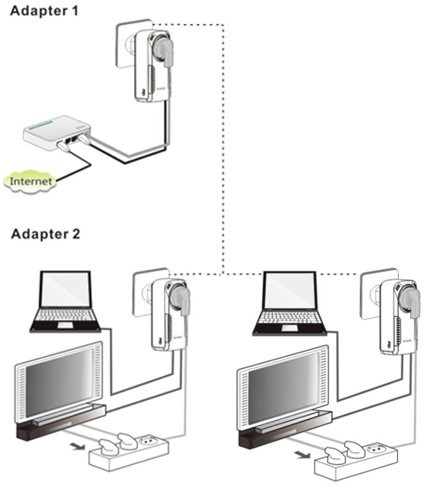
The steps of setting:
❶ Please keep pressing the Pair/Reset button of the powerline adapter, 3 for 1~3 seconds, its PLC light will blink, which means the powerline aapter 3 is checking the network N1.

❷ Please keep pressing the Pair/Reset button of the powerline adapter 1 for 1~3 seconds in 2 minutes, its PLC light will blink, which means they are pairing automatically.
The powerline adapter 3 adds into the private network N1 successfully when PLC light should be on stably.

3 The powerline adapter disconnects the private network.
- For example：The powerline adapter 1, adapter 2 and adapter 3 have established the private network, but the powerline adapter 3 disconnects the private network.
The steps of setting:
Please keep pressing the Pair/Reset button of the powerline adapter 3 for up 6 seconds, its PLC light will blink for three times, which means it disconnects the private network and restores to the factory default setting.

